DEPARTMENT OF COMPUTER SCIENCE AND ENGINEERING

Assessment Tool 1 – Analytical Problem

COURSE NAME: Theory of Computation COURSE CODE: CSA13

COURSE OUTCOME COVERED

CO1: Apply mathematical foundations such as formal proofs, induction, and basic concepts of automata theory to solve computational problems.(BL:3)

Assessment Tool Weightage: 40%

QUESTIONS: 5 Total Marks:50
Duration : 1 Hour

Analytical Problem

Code of Conduct:

I (Name / Reg No) certify that this submission is my original work and that I have adhered to the guidelines specified for this assessment.
I understand that any violation of academic integrity rules will result in disciplinary action.

Signature of the student:

DEPARTMENT OF COMPUTER SCIENCE AND ENGINEERING
Analytical Problem

Rno. 1 to 10

- Consider the NFA given below which accepts some language L over the alphabet 𝚺={a,b}.
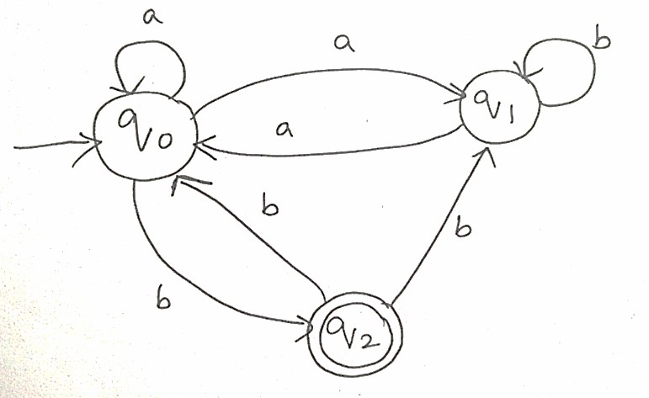
Construct a DFA that represents the same language L
- Let L be the language of words of length atleast 2 whose last two letters are difference from each other. For example abaab is in L but not bb, Construct an NFA for L, Then draw the equivalent DFA

RUBRICS FOR CALCULATION

Criteria | Weightag e | Q1 (10) | Q2 (10) | Q3 (10) | Q4 (10) | Q5 (10) | Total Marks  (50)

DEPARTMENT OF COMPUTER SCIENCE AND ENGINEERING

Conceptual Understandi ng
Accuracy of
Answer
Application of
Knowledge
Completene ss of
Response
Clarity & Presentatio
n
Total per
Question

